Pew Research Center

The Millennials: Confident. Connected. Open to Change.

Overview
Generations, like people, have personalities, and Millennials -- the American teens and twenty-somethings who are making the passage into adulthood at the start of a new millennium -- have begun to forge theirs: confident, self-expressive, liberal, upbeat and open to change.
They are more ethnically and racially diverse than older adults. They're less religious, less likely to have served in the military, and are on track to become the most educated generation in American history.
Their entry into careers and first jobs has been badly set back by the Great Recession, but they are more upbeat than their elders about their own economic futures as well as about the overall state of the nation.(See chapter 4 in the full report)
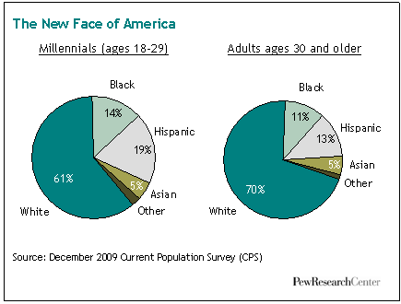
They embrace multiple modes of self-expression. Three-quarters have created a profile on a social networking site. One-in-five have posted a video of themselves online. Nearly four-in-ten have a tattoo (and for most who do, one is not enough: about half of those with tattoos have two to five and 18% have six or more). 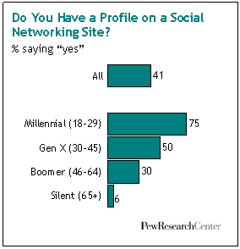Nearly one-in-four have a piercing in some place other than an earlobe -- about six times the share of older adults who've done this. But their look-at-me tendencies are not without limits. Most Millennials have placed privacy boundaries on their social media profiles. And 70% say their tattoos are hidden beneath clothing. (See chapters 4 and 7 in the full report)
Despite struggling (and often failing) to find jobs in the teeth of a recession, about nine-in-ten either say that they currently have enough money or that they will eventually meet their long-term financial goals. But at the moment, fully 37% of 18- to 29-year-olds are unemployed or out of the workforce, the highest share among this age group in more than three decades. Research shows that young people who graduate from college in a bad economy typically suffer long-term consequences -- with effects on their careers and earnings that linger as long as 15 years.¹ (See chapter 5 in the full report)
Whether as a by-product of protective parents, the age of terrorism or a media culture that focuses on dangers, they cast a wary eye on human nature. Two-thirds say "you can't be too careful" when dealing with people. Yet they are less skeptical than their elders of government. More so than other generations, they believe government should do more to solve problems. (See chapter 8 in the full report).
They are the least overtly religious American generation in modern times. One-in-four are unaffiliated with any religion, far more than the share of older adults when they were ages 18 to 29. Yet not belonging does not necessarily mean not believing. Millennials pray about as often as their elders did in their own youth. (See chapter 9 in the full report)
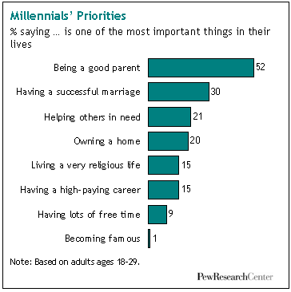Only about six-in-ten were raised by both parents -- a smaller share than was the case with older generations. In weighing their own life priorities, Millennials (like older adults) place parenthood and marriage far above career and financial success. But they aren't rushing to the altar. Just one-in-five Millennials (21%) are married now, half the share of their parents' generation at the same stage of life. About a third (34%) are parents, according to the Pew Research survey. We estimate that, in 2006, more than a third of 18 to 29 year old women who gave birth were unmarried. This is a far higher share than was the case in earlier generations.² (See chapters 2 and 3 in the full report)
Millennials are on course to become the most educated generation in American history, a trend driven largely by the demands of a modern knowledge-based economy, but most likely accelerated in recent years by the millions of 20-somethings enrolling in graduate schools, colleges or community colleges in part because they can't find a job. Among 18 to 24 year olds a record share -- 39.6% -- was enrolled in college as of 2008, according to census data. (See chapter 5 in the full report)
They get along well with their parents. Looking back at their teenage years, Millennials report having had fewer spats with mom or dad than older adults say they had with their own parents when they were growing up. And now, hard times have kept a significant share of adult Millennials and their parents under the same roof. About one-in-eight older Millennials (ages 22 and older) say they've "boomeranged" back to a parent's home because of the recession. (See chapters 3 and 5 in the full report)
They respect their elders. A majority say that the older generation is superior to the younger generation when it comes to moral values and work ethic. Also, more than six-in-ten say that families have a responsibility to have an elderly parent come live with them if that parent wants to. By contrast, fewer than four-in-ten adults ages 60 and older agree that this is a family responsibility.
Despite coming of age at a time when the United States has been waging two wars, relatively few Millennials -- just 2% of males -- are military veterans. At a comparable stage of their life cycle, 6% of Gen Xer men, 13% of Baby Boomer men and 24% of Silent men were veterans. (See chapter 2 in the full report)
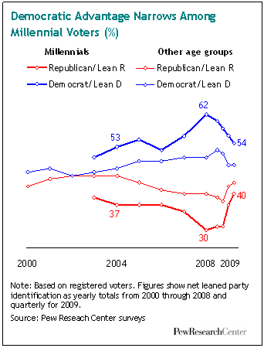Politically, Millennials were among Barack Obama's strongest supporters in 2008, backing him for president by more than a two-to-one ratio (66% to 32%) while older adults were giving just 50% of their votes to the Democratic nominee. This was the largest disparity between younger and older voters recorded in four decades of modern election day exit polling. Moreover, after decades of low voter participation by the young, the turnout gap in 2008 between voters under and over the age of 30 was the smallest it had been since 18- to 20-year-olds were given the right to vote in 1972. (See chapter 8 in the full report)
But the political enthusiasms of Millennials have since cooled -- for Obama and his message of change, for the Democratic Party and, quite possibly, for politics itself. About half of Millennials say the president has failed to change the way Washington works, which had been the central promise of his candidacy. Of those who say this, three-in-ten blame Obama himself, while more than half blame his political opponents and special interests.
To be sure, Millennials remain the most likely of any generation to self-identify as liberals; they are less supportive than their elders of an assertive national security policy and more supportive of a progressive domestic social agenda. They are still more likely than any other age group to identify as Democrats. Yet by early 2010, their support for Obama and the Democrats had receded, as evidenced both by survey data and by their low level of participation in recent off-year and special elections. (See chapter 8 in the full report)

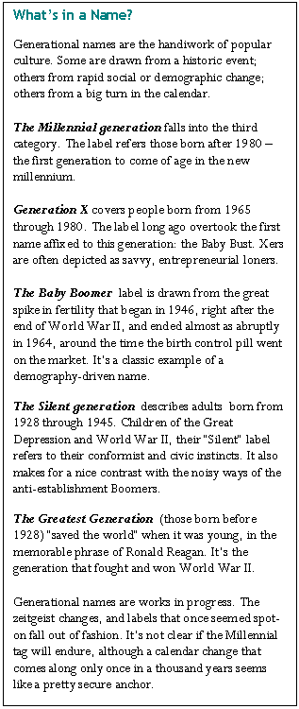Our Research Methods
This Pew Research Center report profiles the roughly 50 million Millennials who currently span the ages of 18 to 29. It's likely that when future analysts are in a position to take a fuller measure of this new generation, they will conclude that millions of additional younger teens (and perhaps even pre-teens) should be grouped together with their older brothers and sisters. But for the purposes of this report, unless we indicate otherwise, we focus on Millennials who are at least 18 years old.
We examine their demographics; their political and social values; their lifestyles and life priorities; their digital technology and social media habits; and their economic and educational aspirations. We also compare and contrast Millennials with the nation's three other living generations-Gen Xers (ages 30 to 45), Baby Boomers (ages 46 to 64) and Silents (ages 65 and older). Whenever the trend data permit, we compare the four generations as they all are now -- and also as older generations were at the ages that adult Millennials are now.³
Most of the findings in this report are based on a new survey of a national cross-section of 2,020 adults (including an oversample of Millennials), conducted by landline and cellular telephone from Jan. 14 to 27, 2010; this survey has a margin of error of plus or minus 3.0 percentage points for the full sample and larger percentages for various subgroups (for more details, see page 110 in the full report). The report also draws on more than two decades of Pew Research Center surveys, supplemented by our analysis of Census Bureau data and other relevant studies.

Some Caveats
A few notes of caution are in order. Generational analysis has a long and distinguished place in social science, and we cast our lot with those scholars who believe it is not only possible, but often highly illuminating, to search for the unique and distinctive characteristics of any given age group of Americans. But we also know this is not an exact science.
We acknowledge, for example, that there is an element of false precision in setting hard chronological boundaries between the generations. Can we say with certainty that a typical 30-year-old adult is a Gen Xer while a typical 29-year-old adult is a Millennial? Of course not.
Nevertheless, we must draw lines in order to carry out the statistical analyses that form the core of our research methodology. And our boundaries -- while admittedly too crisp -- are not arbitrary. They are based on our own research findings and those of other scholars.
We are mindful that there are as many differences in attitudes, values, behaviors and lifestyles within a generation as there are between generations. But we believe this reality does not diminish the value of generational analysis; it merely adds to its richness and complexity. Throughout this report, we will not only explore how Millennials differ from other generations, we will also look at how they differ among themselves.

The Millennial Identity
Most Millennials (61%) in our January 2010 survey say their generation has a unique and distinctive identity. That doesn't make them unusual, however. Roughly two-thirds of Silents, nearly six-in-ten Boomers and about half of Xers feel the same way about their generation.
But Millennials have a distinctive reason for feeling distinctive. In response to an open-ended follow-up question, 24% say it's because of their use of technology. Gen Xers also cite technology as their generation's biggest source of distinctiveness, but far fewer -- just 12% -- say this. Boomers' feelings of distinctiveness coalesce mainly around work ethic, which 17% cite as their most prominent identity badge. For Silents, it's the shared experience of the Depression and World War II, which 14% cite as the biggest reason their generation stands apart. (See chapter 3 in the full report)
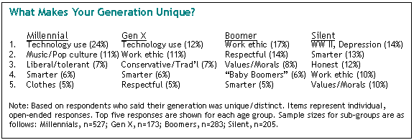
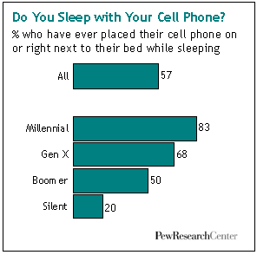Millennials' technological exceptionalism is chronicled throughout the survey. It's not just their gadgets -- it's the way they've fused their social lives into them. For example, three-quarters of Millennials have created a profile on a social networking site, compared with half of Xers, 30% of Boomers and 6% of Silents. There are big generation gaps, as well, in using wireless technology, playing video games and posting self-created videos online. Millennials are also more likely than older adults to say technology makes life easier and brings family and friends closer together (though the generation gaps on these questions are relatively narrow). (See chapter 4 in the full report)

Work Ethic, Moral Values, Race Relations
Of the four generations, Millennials are the only one that doesn't cite "work ethic" as one of their principal claims to distinctiveness. A nationwide Pew Research Center survey taken in 2009 may help explain why. This one focused on differences between young and old rather than between specific age groups. Nonetheless, its findings are instructive.
Nearly six-in-ten respondents cited work ethic as one of the big sources of differences between young and old. Asked who has the better work ethic, about three-fourths of respondents said that older people do. By similar margins, survey respondents also found older adults have the upper hand when it comes to moral values and their respect for others.
It might be tempting to dismiss these findings as a typical older adult gripe about "kids today." But when it comes to each of these traits -- work ethic, moral values, respect for others -- young adults agree that older adults have the better of it. In short, Millennials may be a self-confident generation, but they display little appetite for claims of moral superiority.
That 2009 survey also found that the public -- young and old alike -- thinks the younger generation is more racially tolerant than their elders. More than two decades of Pew Research surveys confirm that assessment. In their views about interracial dating, for example, Millennials are the most open to change of any generation, followed closely by Gen Xers, then Boomers, then Silents.
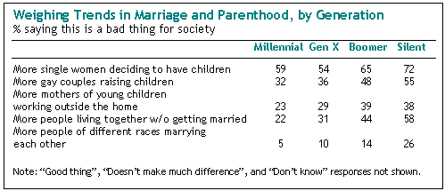
Likewise, Millennials are more receptive to immigrants than are their elders. Nearly six-in-ten (58%) say immigrants strengthen the country, according to a 2009 Pew Research survey; just 43% of adults ages 30 and older agree.
The same pattern holds on a range of attitudes about nontraditional family arrangements, from mothers of young children working outside the home, to adults living together without being married, to more people of different races marrying each other. Millennials are more accepting than older generations of these more modern family arrangements, followed closely by Gen Xers. To be sure, acceptance does not in all cases translate into outright approval. But it does mean Millennials disapprove less. (See chapter 6 in the full report)

A Gentler Generation Gap
A 1969 Gallup survey, taken near the height of the social and political upheavals of that turbulent decade, found that 74% of the public believed there was a "generation gap" in American society. Surprisingly, when that same question was asked in a Pew Research Center survey last year -- in an era marked by hard economic times but little if any overt age-based social tension -- the share of the public saying there was a generation gap had risen slightly to 79%.
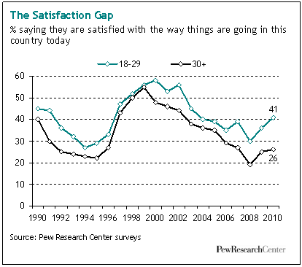But as the 2009 results also ake clear, this modern generation gap is a much more benign affair than the one that cast a shadow over the 1960s. The public says this one is mostly about the different ways that old and young use technology -- and relatively few people see that gap as a source of conflict. Indeed, only about a quarter of the respondents in the 2009 survey said they see big conflicts between young and old in America. Many more see conflicts between immigrants and the native born, between rich and poor, and between black and whites.
There is one generation gap that has widened notably in recent years. It has to do with satisfaction over the state of the nation. In recent decades the young have always tended to be a bit more upbeat than their elders on this key measure, but the gap is wider now than it has been in at least twenty years. Some 41% of Millennials say they are satisfied with the way things are going in the country, compared with just 26% of those ages 30 and older. Whatever toll a recession, a housing crisis, a financial meltdown and a pair of wars may have taken on the national psyche in the past few years, it appears to have hit the old harder than the young. (See chapter 3 in the full report)
But this speaks to a difference in outlook and attitude; it's not a source of conflict or tension. As they make their way into adulthood, Millennials have already distinguished themselves as a generation that gets along well with others, especially their elders. For a nation whose population is rapidly going gray, that could prove to be a most welcome character trait.

A Portrait of Generation Next
Source Organization: Pew Research Center
Author: Tom Ferrick Jr.
11/18/2010 - It is a sign of their thoroughness—or perhaps of their innate intensity—that when the folks at the Pew Research Center decided to study Americans who are aged 18 to 29, they devised surveys that not only asked whether members of this new generation had a cell phone (94 percent do). They also asked if they kept the cell with them or next to the bed while they slept (yes, said 83 percent).
They asked them if they used their cells to send and receive text messages (88 percent do), and they also asked if they texted while driving (64 percent admitted to that bad habit).
In the same way—and perhaps in an even greater sign of the researchers’ intensity—they also asked these young Americans not just “Do you have a tattoo?” but how many and where the tattoos were located. (For the record, nearly 4 in 10 do, more than half of them have more than two, but the majority keeps them hidden under clothes.)
These were just a few of the questions on the surveys, but they give a sense of how the center’s researchers went about their mission. They clearly did not want to skim the surface. They wanted to dig down so they could capture the psyche, habits and beliefs of this new generation and explain it to the rest of us. They succeeded.
When the report, Millennials: A Portrait of Generation Next, was released early this year, it caused a stir in the media. The adjective most often applied to the study was exhaustive. But what caused the public to sit up and pay attention was the way the report rendered a portrait of a distinctive generation, different in many ways from those who came before it and one which has already had real political impact. It was a theme signaled in the opening paragraph of the report:
“Generations, like people, have personalities and Millennials—American teens and twenty-somethings who are making the passage into adulthood at the start of a new millennium—have begun to forge theirs: confident, selfexpressive, liberal, upbeat and open to change.”
The author of that passage was Paul Taylor, the center’s executive vice president. His principal co-author was Scott Keeter, the center’s director of survey research.
They represent the two sides of the center’s brain. Taylor, 61, is a former reporter who spent 25 years as a journalist, principally with The Philadelphia Inquirer and The Washington Post. Keeter, 59, is an expert on survey research and the author of four books on politics and demographic change.
The Millennial report—as with most of the center’s many reports—is infused with what Taylor described as a “mix of journalistic story-telling sensibility with authoritative research and scientific method.”
In an interview at the center’s L Street headquarters in Washington, DC, Taylor and Keeter explained that the report was truly a collaborative effort, involving most of the seven entities that comprise the center and make it—in the words of its president, Andrew Kohut—a “fact tank.” More about that later.
The more immediate point is that Taylor and Keeter are bona fide Baby Boomers, the generation that has gotten most of the ink over the years. As Kohut put it in his remarks on the day the Millennial report was issued, “For a long time, it’s been my view that young people were out of fashion.”
When asked about Kohut’s remarks, Keeter agreed, saying, “The shadow of the Baby Boomers was a very long one, both because of the size of the generation and the cultural changes that accompanied its coming of age. Subsequent generations have gotten less attention, simply because of the size of the Baby Boomer cohort, but some of it is that as the Boomers got older, they took over the narrative of the country—and may have wanted to keep the spotlight on themselves.”
The spotlight shifted in 2008, as Millennials made their presence felt in a significant way in the presidential election. Not only did they vote at a much higher level than ever before, they embraced the candidacy of Barack Obama. Voters under 30 gave Obama 66 percent of their vote, compared to the 50 percent share he got from voters older than 30.
Young people were back in fashion. But the question arose: who exactly were these Millennials? Taylor, Keeter and their colleagues at the center decided to look for answers.
WHAT’S IN A NAME?
We love to apply labels, and there are popular names given to each of the five generations co-existing in America today. The oldest are called the Greatest Generation because they were the ones who fought and won World War II. They are followed by the Silent Generation. Next came the Baby Boomers and then Generation X. Millennials are the generation born after 1980 who reached adulthood after the turn of the century—the beginning of a new millennium.
There is arbitrariness to these labels: who is to say that someone who is 29 is a Millennial and someone who is 30 is automatically a Gen Xer? There are Millennials who neither own nor use cell phones, albeit very few. But, as the center’s studies illustrate, generational analysis can be useful and insightful, even though it requires that boundaries be drawn around certain age groups.
There are 50 million Americans between the ages of 18 and 29 today. We know from census data that this group is more diverse than older Americans, with a higher proportion of blacks and Hispanics. Sixty-one percent of Millennials are white, compared to 70 percent for adults 30 and older.
For the rest, we look to the Millennial report and parse its opening paragraph, adding detail.
Millennials are confident…
They have reason to be. They are headed towards being the most educated generation in American history, and 61 percent think of their own age group as distinct and unique. What makes them so?
Asked an open-ended question, Millennials cited five factors most frequently: 24 percent said it was their use of technology, 11 percent their music and pop culture, 7 percent said it was because they were liberal and tolerant, 6 percent said they were smarter than other generations and 5 percent cited their clothes. (Don’t be put off by their claims of being smarter. Every generation mentioned it in the survey.)
The Millennials seem to have a love of technology—and technological competence—embedded in their DNA. As the report puts it, “They are history’s first ‘always connected’ generation, steeped in digital technology and social media, they treat their multi-tasking hand-held gadgets almost as a body part—for better or worse.”
Three-quarters of them have a profile posted on a social networking site, such as Facebook. One-fifth of them have posted videos of themselves online.
Millennials are self-expressive…
The Facebook profiles. The personal videos posted online. The tattoos. The body-piercing (23 percent have piercing at some place on their body other than their earlobes). Taylor believes the self-expressiveness is a manifestation of their confidence. “Part of the reason [for their confidence] is that they do feel empowered by their moment in history and their technology use,” he said. “And some of the technology use is ‘all about me.’ The online behavior is ‘Hey, look at me. Look at what I’m doing.’ The off-line behavior—with the tattoos—is also ‘Hey, look at me.’”
This can also be read as indicating Millennials are selfabsorbed, but that may be more of a function of youth and not this particular generation.
On other levels, they are generous in their judgments of older generations. For instance, in previous surveys done by the center, older people have expressed the belief that they have better values, work ethic and more respect for others. Millennials agree.
They may be saying “We’ve different,” but they are not saying “We’re better.”
Unlike the Baby Boomers, there is very little conflict among the generations. As Taylor put it: “Millennials say, ‘We are different from Mom and Dad, but we are all cool.’”
Millennials are liberal…
Not only when it comes to politics, but also on most social issues.
In 2008, 62 percent of Millennials identified themselves as Democrat or as leaning Democratic, the highest support for the party among all age groups. In the same year, 66 percent of the Millennial vote went for Barack Obama and only 32 percent for Republican John McCain in the presidential race.
These are staggeringly high numbers, but they are not set in stone. More recent data collected by the center shows a drop in support for President Obama and the Democrats among Millennials. Although the president remains personally popular among 18- to 29-year-olds (with a 65 percent approval rating), his job-rating declined among younger and older voters as 2009 progressed.
Why are Millennials liberal?
“A combination of things,” said Keeter. “First, this is a diverse generation and its liberalism is tied up in its racial and ethnic identity. You have a significant percentage being nonwhite, and being nonwhite in America is associated with being less conservative and more liberal. Second, they have come of age in a time when rapid changes in social mores had occurred and is still occurring and they internalized these as tolerant, progressive and liberal.”
For instance, Millennials are the only generation that favors gay marriage (50 to 36 percent, with the remainder undecided). Whether the issue is interracial dating, affirmative action, same-sex adoptions, immigration or favoring an activist government, Millennials land consistently on the liberal side. They grew up with the culture wars in America and they are taking sides with the progressives.
As Keeter pointed out, another factor in the Millennials’ liberalism may be related to their relationship to organized religion. Fully one-quarter of 18- to 29-year-olds say they are not affiliated with any church, and those who are affiliated tend to go less frequently than their elders. Participation in religion is often a marker for conservatism.
Millennials are upbeat and open to change…
No one would criticize Millennials if they were angry or depressed. The recession has hit them with full force, stopping many of them from even getting the first foot on the career ladder. Yet they remain optimistic about the future and have a higher satisfaction level (41 percent) when it comes to the state of the nation than do those over 30 (26 percent).
They do not blame the government for their problems, nor are they cynical about big business.
While there is evidence that a long stretch of low wages and unemployment can harm a person’s earning potential in the long run, the Millennials think they will be okay. As Taylor noted, young people are not marching on City Hall or taking over the dean’s office to protest the state of the world.
“As we well know, there is an angry populace out there, but it is basically not these kids,” Taylor said. “It is the older folks who feel dislocated. But these kids are out there putting one foot in front of another and doing the best they can. I find that to be—maybe surprising is not the right word—but distinguishing.”
We’ve talked so much about how Millennials differ from other generations that it would be wise to mention some similarities. What Millennials say they want out of life is very similar to what older generations want: being a good parent, having a successful marriage, helping others in need are their life priorities. Fame and wealth are low on the list.
Significantly, as a sign of their respect for their elders, 63 percent of Millennials state that adult children should allow an elderly parent to live in their homes, if that is what the parent wants to do. This is in line with the attitude of Gen Xers (67 percent say parents should be allowed) but higher than Baby Boomers (55 percent) and the Silent Generation (38 percent).
Some of the data in the report is based on a telephone survey of 2,020 people—via landline and cell phones—that was taken in January, 2010. All generations were surveyed, but Millennials were over sampled.
But that is only part of the story.
A CULMINATION
In a way, the Millennial report represents a culmination of years of polling by the Pew Research Center. The center’s continuing work on the new generation marks the first collaboration by all of its seven entities and projects: the Center for the People and the Press, the Project for Excellence in Journalism, the Internet & American Life Project, the Forum on Religion and Public Life, the Hispanic Center, the Global Attitudes Project and the most recent addition, the Social and Demographic Trends Project.
The oldest is the Pew Center for the People and the Press, which was created 15 years ago with Kohut, a veteran of the Gallup Organization, who headed the Times Mirror Center for the People & the Press. (Pew took the center under its wing when the Times Mirror Company decided to stop funding it.)
In 2004, the entities consolidated under the umbrella of the Pew Research Center, a subsidiary of The Pew Charitable Trusts, with Kohut as president and Taylor as executive vice president. The way Taylor describes it: “This was a collection of colonies before it was the United States.”
Each entity had its own identity and mission so, Taylor said, “Our notion was ‘First, do no harm.’ We basically said that we may get some collaborations, but let us not force it.”
The Millennial project offered an opportunity at true collaboration across the various entities at the center. It was born out of an understanding after the 2008 election that the 18- to 29-year-old generation was coming into its own, certainly politically.
“We were only going to do this if we had something that thematically made sense and was the kind of topic that could march its way across the centers,” Taylor said. “And the Millennial project was sort of the first one that rose to that challenge. The original hope that this could be greater than the sum of its parts has been proven true.”
All of the Pew Research Center’s studies are rich with information, but they are not simply a collection of numbers.
“The sweet spot is to be very aggressive in presenting not just a whole bunch of numbers, but also an analysis of over how those numbers relate—and over time,” Taylor said. “It’s everything that goes into good journalism—except that we stop short of making inferences from the numbers.”
The Millennial report, for example, does not speculate on the future. It will let the future arrive and then survey and probe on how the 18- to 29-year-old generation has—or has not—changed. One of the purposes of this study was to set a baseline for information on the Millennials, in the same way Kohut and the center’s researchers have gathered information on other generations over a number of decades.
But it is tempting to speculate on what impact Millennials will have on politics and on society in the future. The potential is for the Millennials, who are expected to rival the Baby Boomers in number, to have a significant impact, especially if they keep up their level of voter participation (by no means a sure thing) and their liberal/Democratic tilt.
We know they did have a large role in electing President Obama, and pundits and political observers were quick to declare 2008 a “redefining election”—one that changes the contours of politics.
Keeter and Taylor are not so sure.
“I would say let’s keep our powder dry,” Taylor said. “Does this mean that they will carry those judgments through the rest of their lives? We have to see more of this movie.”
On the societal level, both Taylor and Keeter said they were surprised by two findings outlined in the report: the Millennials’ respect for their elders and their stated willingness to have elderly parents move in with them.
(By the way, the reverse is certainly true. This is the “boomerang generation” that has often returned home to live, especially in these tough economic times. More than one-third of Millennials said they depended on their parents for some financial support.)
As Boomers age and put stress on everything from the health care system to Social Security, it may be a godsend for those elders who need help to have children willing to give it.
“While they are a distinctive generation, they are not a conflictual one,” Taylor said. “They are not wagging their fingers at older folks, saying ‘We know better.’ I think that bodes well for our society. The Boomers are about to cross the threshold of 65, and that will put pressure on our public safety nets. It will be very complicated for our economic and political system. It is potentially a source of generational conflict. I don’t know how it will play out in public policy, but the fact that this [Millennnial] generation is the one that will live with this through its life cycle is surely a good thing. And speaking as a Boomer, it is probably a better break than we deserve.”
In the meantime, the center’s researchers are looking forward to this year’s elections to measure how the Millennials act: Will they turn out to vote or revert to their earlier habit of low participation? Will they continue to trend Democratic or nudge closer to Republican candidates? Answers to come, courtesy of Pew, at a later date. For as thorough as it was, this year’s Pew Research Center Millennials report is just the first chapter on this generation.
Tom Ferrick Jr. is a Pulitzer Prize–winning journalist based in Philadelphia. He last wrote for Trust about the Pew Research Center’s Project for Excellence in Journalism.

